**Creating & Setup Instance in AWS**

## **A. Initial Instance Creation**

1. **Go to EC2 and select "Launch Instance".**
2. **Check the Region:** Before starting, make sure to select the correct region where you want to create the instance (e.g., N. Virginia us-east-1).  
    The selected region is displayed in the top-right corner.
3. **Instance Name:** Provide a name for your instance (e.g., ecommerce).
4. **Select the OS:** Choose the operating system for your instance (e.g., Ubuntu).
5. **Instance Type:** The instance type will be automatically selected as per the free tier eligibility for that region.
6. **Create a Key Pair:**
   * Click on **Generate Key Pair**.
   * Provide a name for your key pair.
   * Set Key Pair Type to **RSA**.
   * Set Private Key Format to **.pem**.
   * **Note:** After generating, the private key file will be downloaded automatically. **Store it safely**, as you’ll need it to connect via the terminal.
7. **Network Settings:**
   * You'll see the VPC (Virtual Private Cloud).
   * Edit the settings if needed and make sure it matches the same VPC as your database (if you’re using AWS RDS).
   * **Important:** The EC2 and database must be in the same VPC for connectivity.
8. **Storage Configuration:**
   * Allocate storage (up to 30GB is free in the Free Tier).
9. **Launch the Instance:**
   * Click on **Launch Instance**.
   * Your instance will be created.

## **B. Connecting to the Instance via AWS Terminal & Local Terminal**

### **Using AWS Terminal (Browser-Based)**

* Click **Connect** from the EC2 dashboard.
* It will automatically open a new tab showing your Ubuntu EC2 instance terminal.

### **Using Local Terminal (PC Command Line)**

1. Remember the private key file you downloaded earlier (e.g., saved in D:/Deployment).
2. Navigate to the directory containing the key file in your terminal:  
    Example:  
    makefile  
   CopyEdit  
   D:\Deployment\Pristine Couture>
3. In the EC2 dashboard, click on **Connect**, and then select the **SSH Client** tab.
4. Copy the SSH connection command from the example provided.
5. Paste the command in your terminal (in the directory where your .pem file is located).
6. It may prompt a security warning. Type **yes** to continue.
7. If you get a "public key is not accessible" error, you need to change the file permissions.  
   * Follow this link to resolve it:  
      [Permission Fix Guide](https://docs.google.com/document/d/1ZUq9VOlOB2Dhh7gtNtMEuP8xNyvqRGtwT6fCooHKD_E/edit?tab=t.2ar2kxue0cgl)
8. After setting the correct permissions, you should be successfully connected to your EC2 instance via your local terminal.

## **C. Setting Security Group Inbound Rules**

### **EC2 Security Group**

1. Go to the **Security Groups** section from the EC2 sidebar.
2. Find and select the **Security Group** attached to your EC2 instance.
3. Click on **Inbound Rules** > **Edit Inbound Rules**.
4. Add the required rules as per your needs (e.g., allow SSH or HTTP).

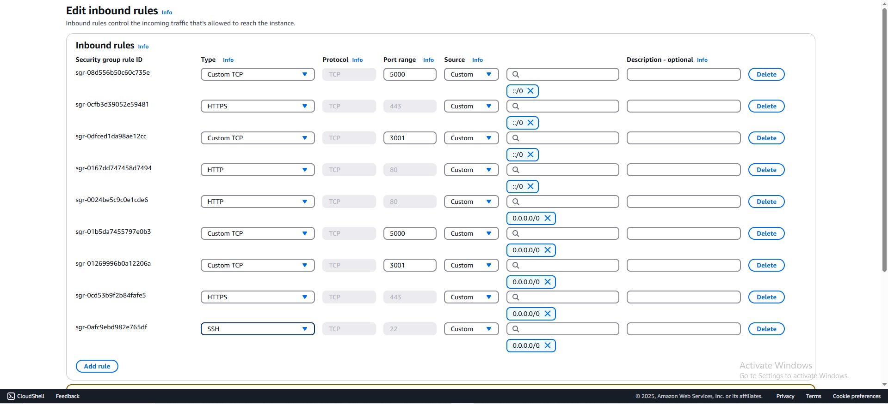

### **D. AWS RDS Security Group**

1. Go to the **Security Group** linked to your RDS database.
2. Click on **Edit Inbound Rules**.
3. Since you're using PostgreSQL, add an inbound rule with the following:  
   * **Type:** PostgreSQL
   * **Source:** Custom
   * **Value:** The **Security Group ID** of your EC2 instance.
4. Click **Save Rules**.

